Create a simple script file and push it to repo. Create a project in Jenkins connected to your GitHub repository. When a commit is made to your repo, automatically build must get triggered from Jenkins and the output must be shared to me via email.
- Created EC2 instance in AWS.
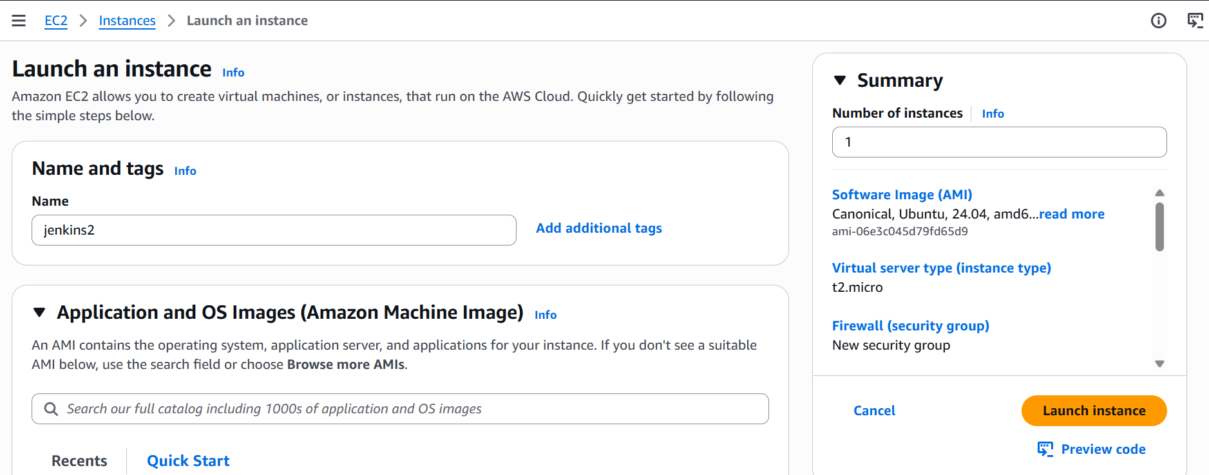

- Connected the EC2 instances using putty(ssh)
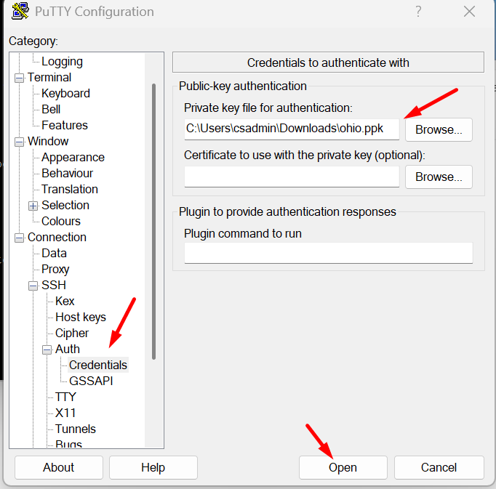
- Steps to Install Jenkins in Ubuntu.
For Jenkins, as a prerequisite we need to install java
sudo apt update
sudo apt install fontconfig openjdk-21-jre
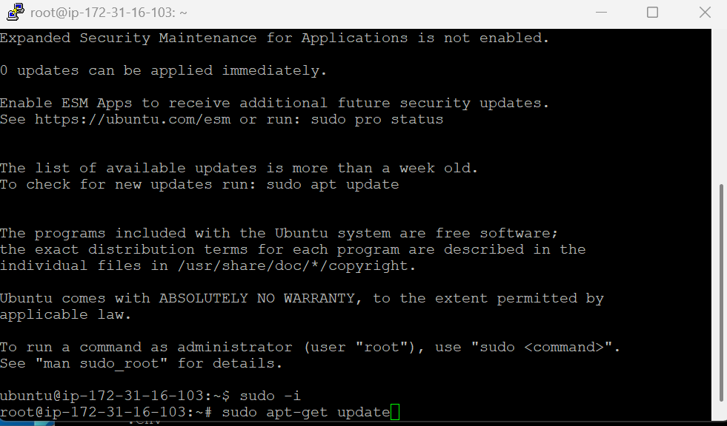
To check the java -version
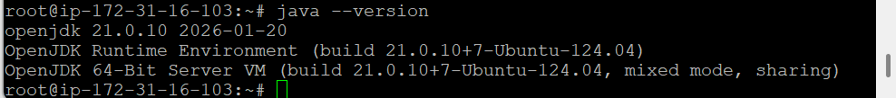

- To install the Jenkins, we need to create the key. Follow the Jenkins installation document.
sudo wget -O /etc/apt/keyrings/jenkins-keyring.asc \
https://pkg.jenkins.io/debian-stable/jenkins.io-2026.key
echo "deb [signed-by=/etc/apt/keyrings/jenkins-keyring.asc]" \
https://pkg.jenkins.io/debian-stable binary/ | sudo tee \
/etc/apt/sources.list.d/jenkins.list > /dev/null

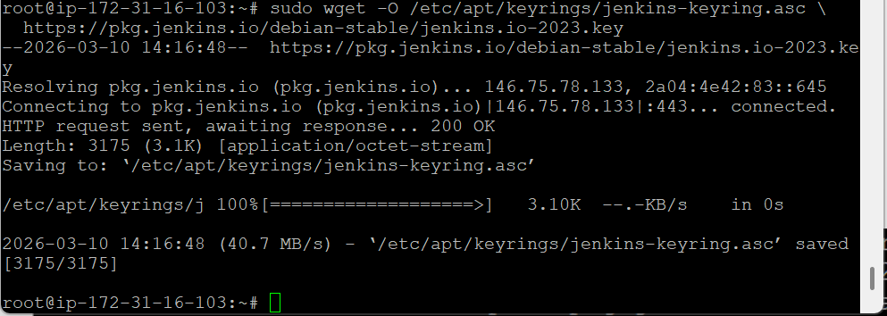
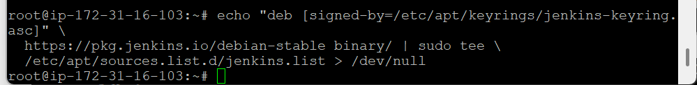

sudo apt update
sudo apt install jenkins
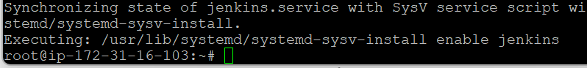

Once completed the installation, start the Jenkins be he below command.
sudo systemctl start jenkins
To Check the status of Jenkins
sudo systemctl status jenkins
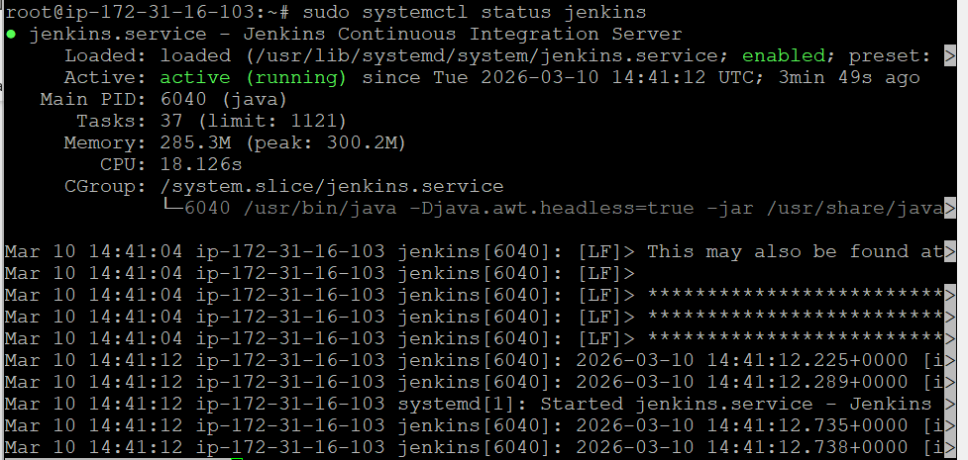
Jenkins will run on Port 8080 by default, so we need to open the port 8080 in EC2 machine in AWS console.
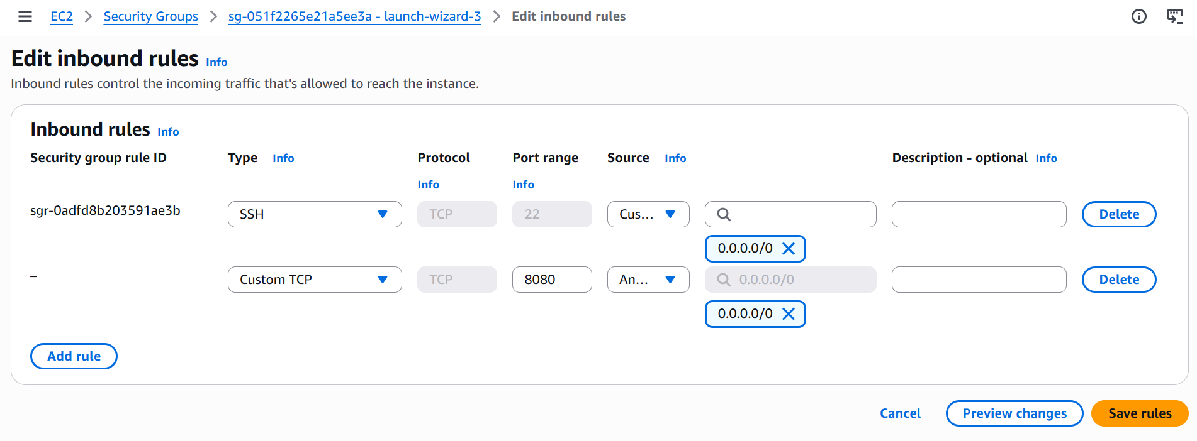

We can access the Jenkins from the browser and we need to create the login credentials using the default admin secret.
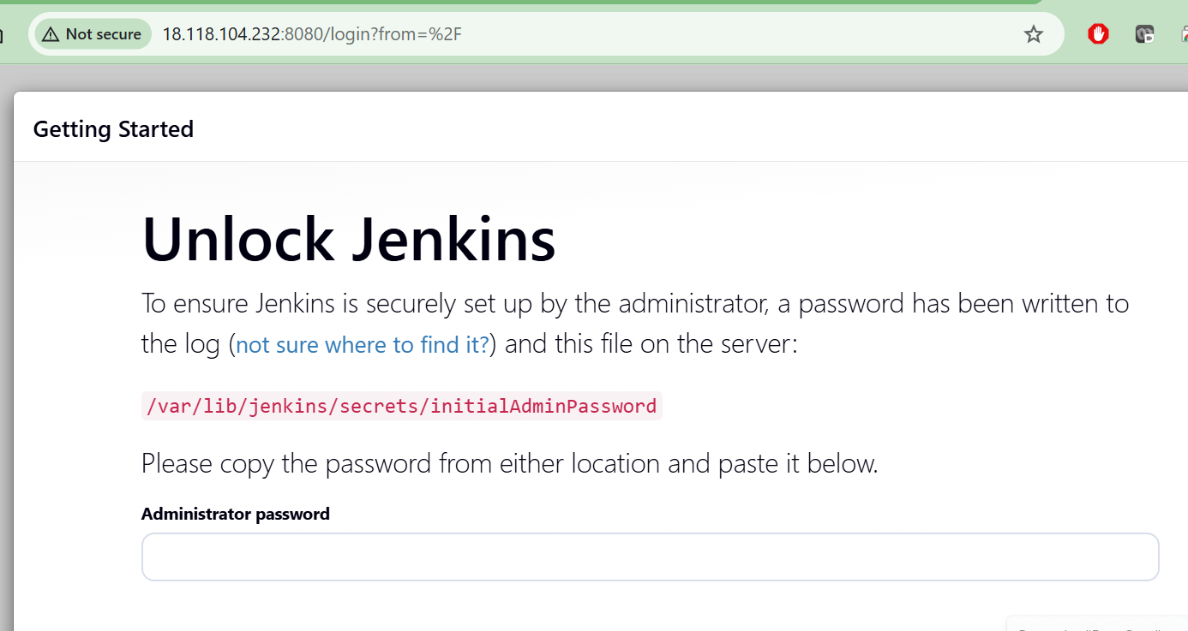

Once logged in to Jenkins, we need to install all the suggested plugins in Jenkins.
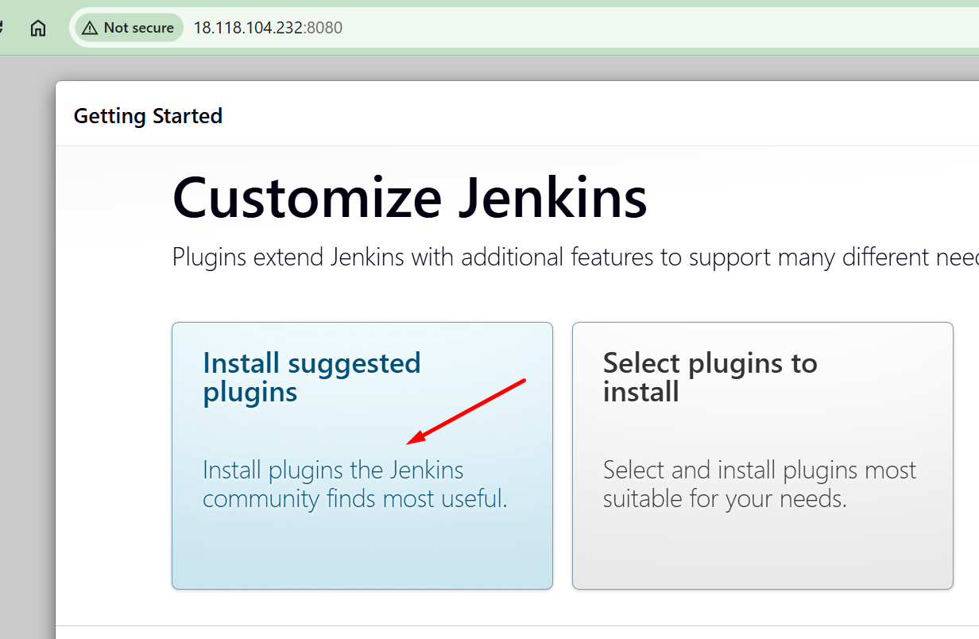
We need to create the first admin user and password.
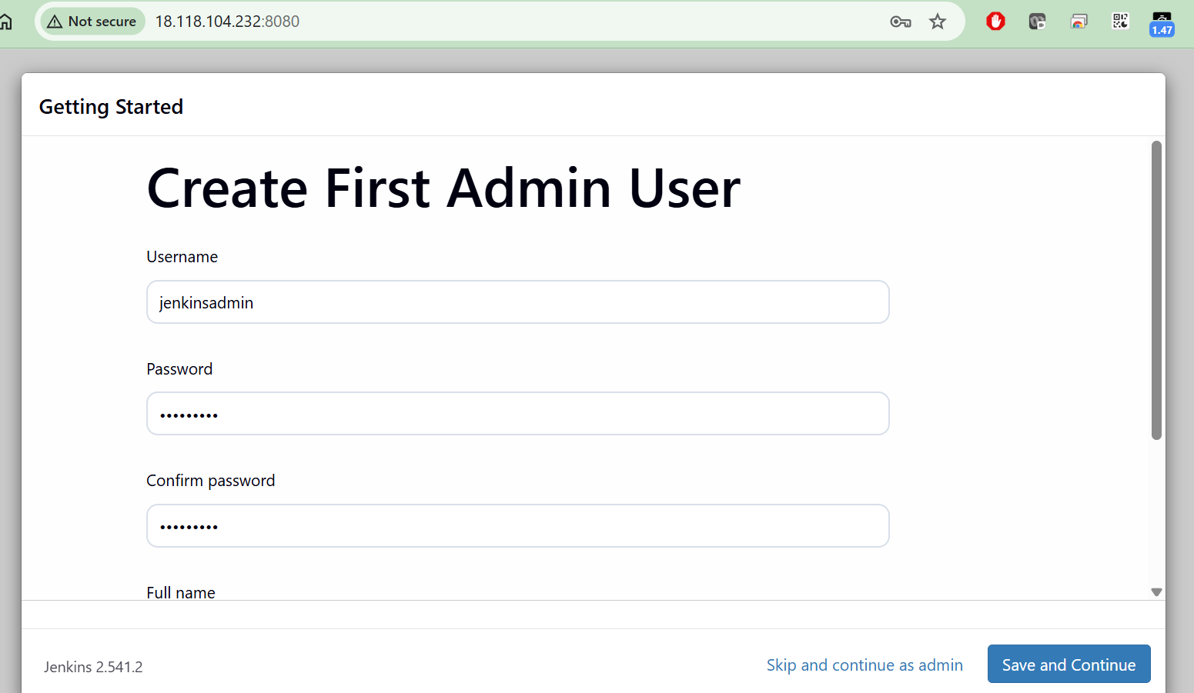

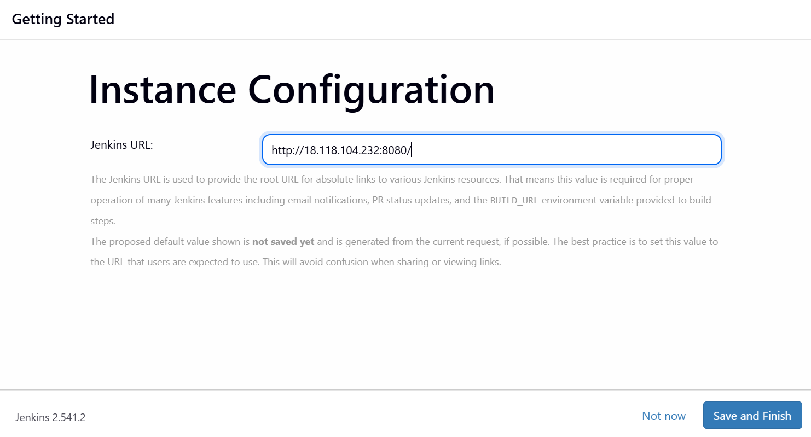
The installation of the Jenkins is completed successfully in an EC2 instance.
Now we can access Jenkins in browser,
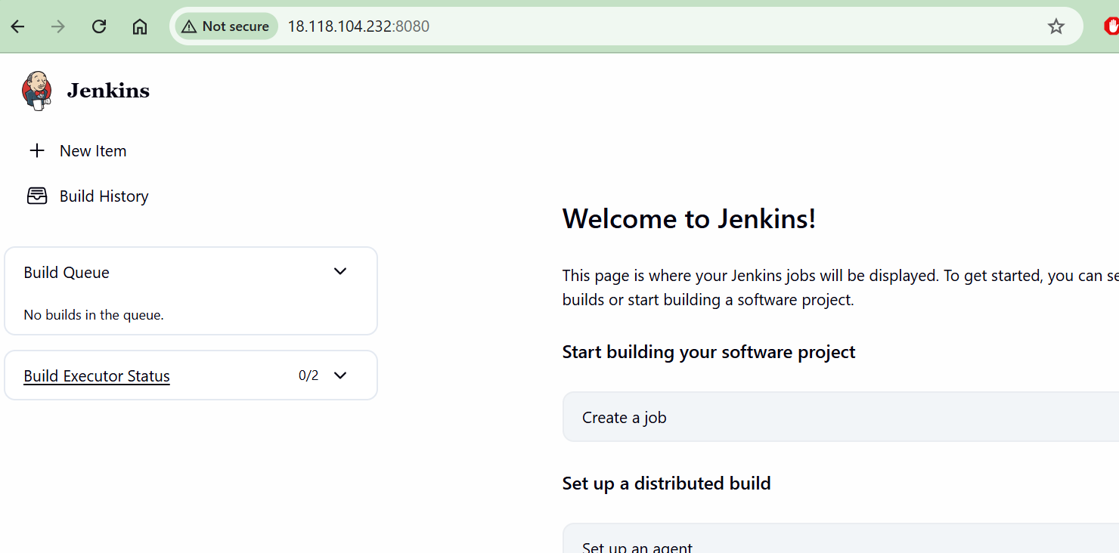
Setup Email notification in Jenkins by installing the Email plugins
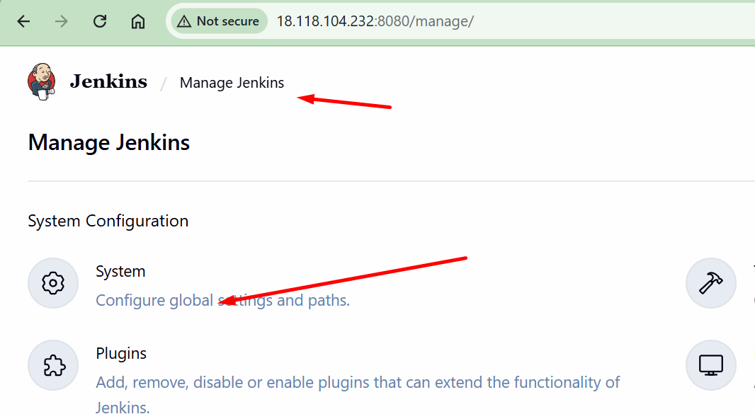
Enter the email server details for gmail its smtp.gmail.com
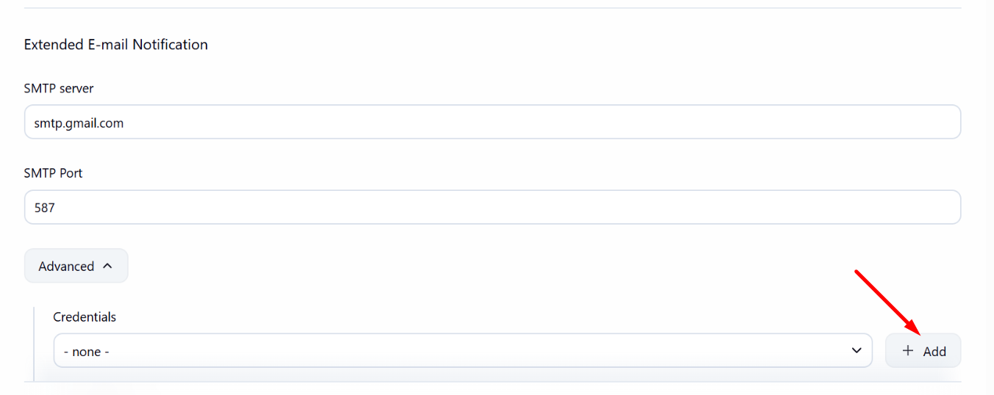
Add the credentils for the emal account for the authentication. Here we need to use the app password for the email account as the normal password not allowed in jenkins.

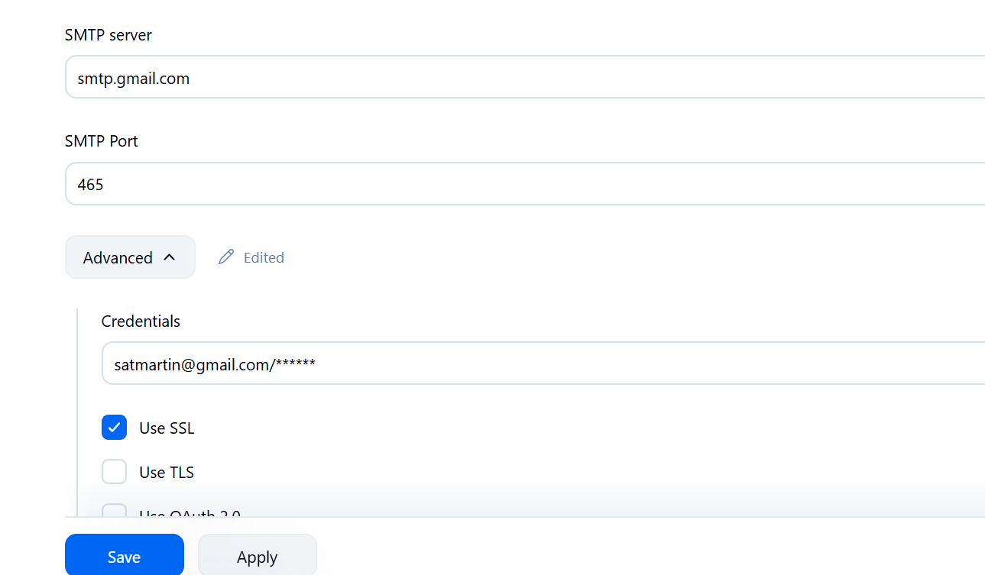

Once completed the email server configuration, send the test email to test it.
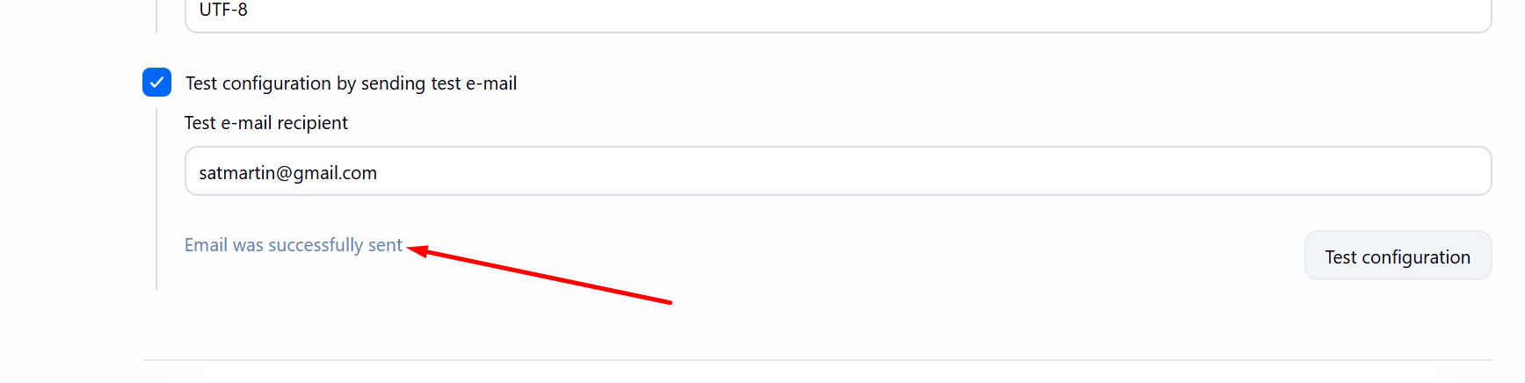
Emails are receiving successfully.
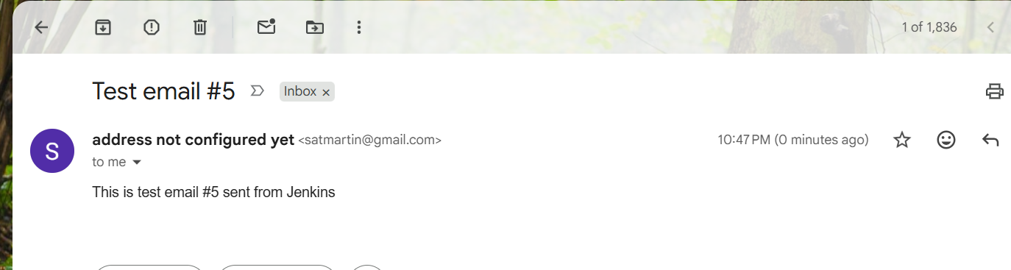

Create a working directory for in EC2 instance for Jenkins task and to create the script to commit it in the Github
mkdir Jenkins-task2
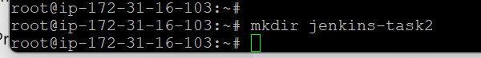
Initiate the Git
git init
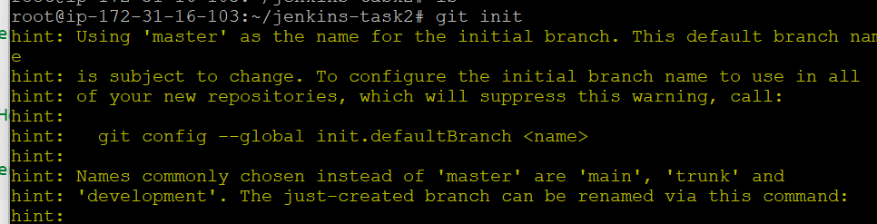

Create a sample script file as shown in below screenshot.
#!/bin/bash
echo "===== Jenkins Build Started ====="
echo "Date:"
date
echo "Server Hostname:"
hostname
echo "===== Jenkins Build Completed ====="

Make the script executable by giving permission
chmod +x jenkins.sh
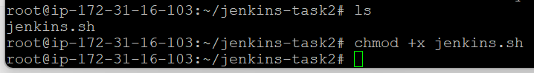

Test it to check its running correctly.
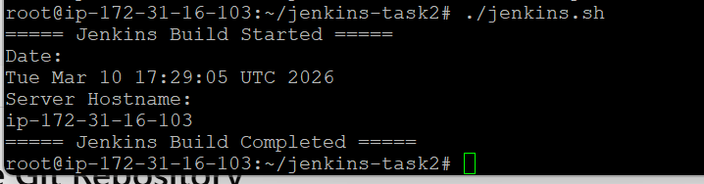
We are getting the expected output.
Config the git from the EC2 instance and add the script file in git.
https://github.com/Satheeskumar84

Make the commit of the script file.

Enter the GitHub repository login credentials for the authentication
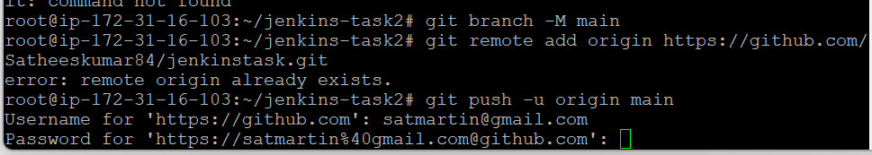

Github doesn’t allow the Username password authentication, so we are trying to authenticate via tokens.
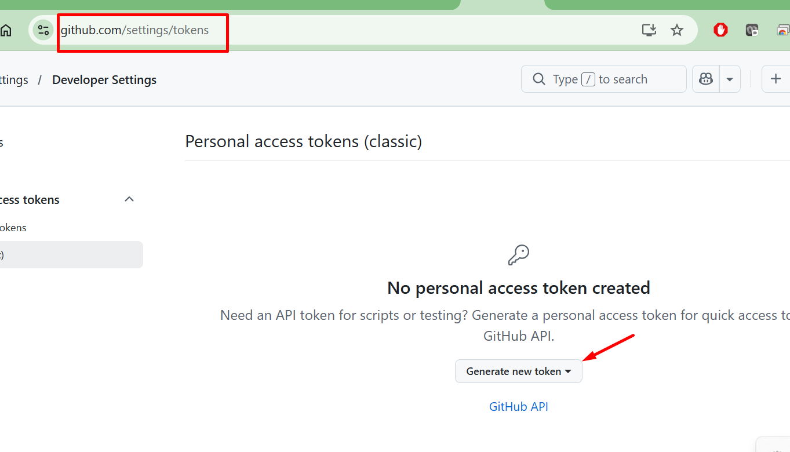
Use the below token for the authentication
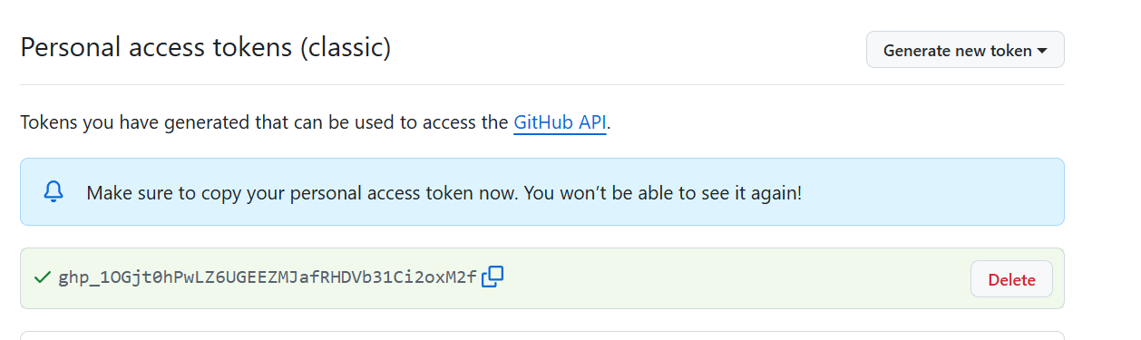
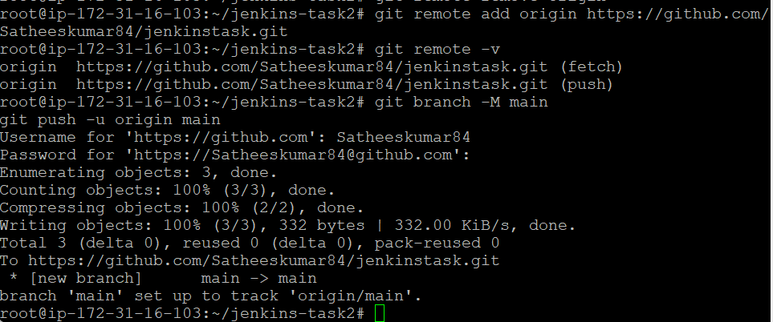

We have successfully pushed the Jenkins.sh script in to the Github from Ec2 instance
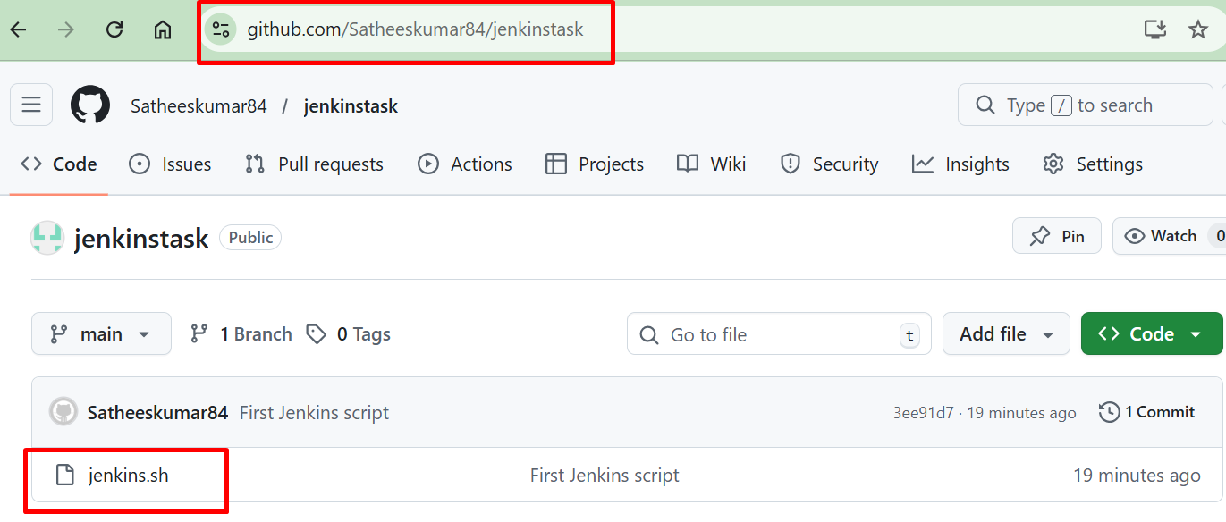

Creating a freestyle Jenkins Job in Jenkins
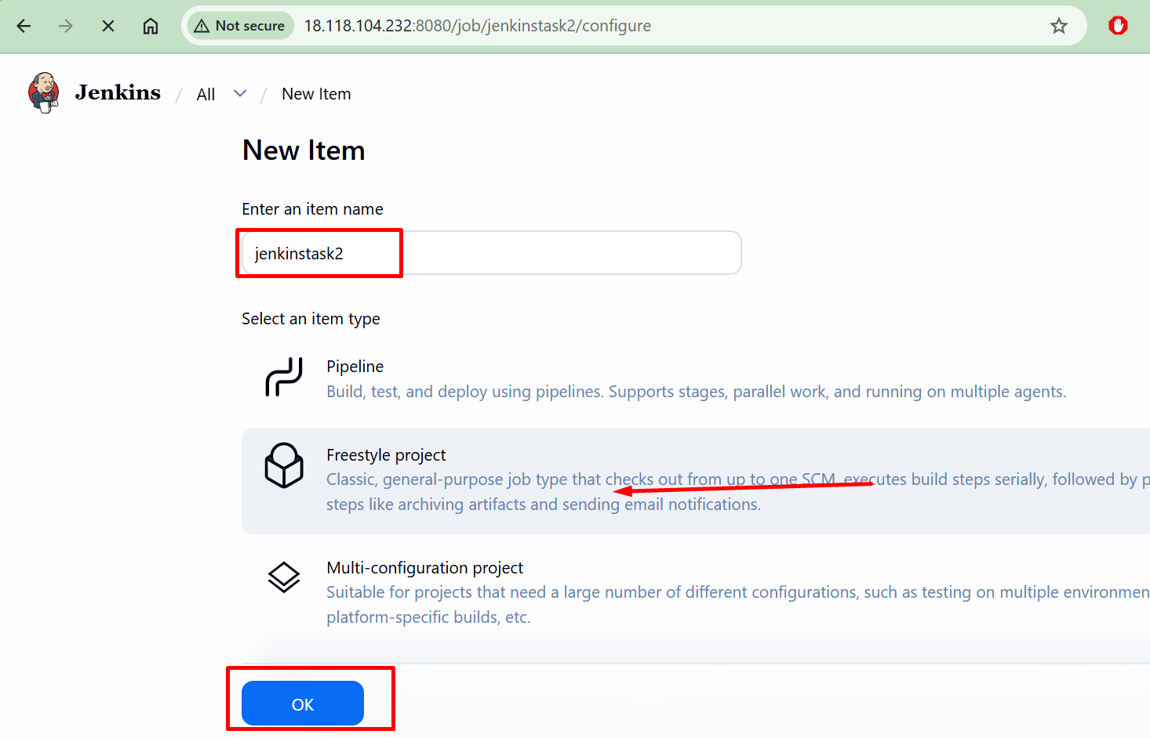
In the “Build steps” of the task configuration area and select the “Execute Shell” option.
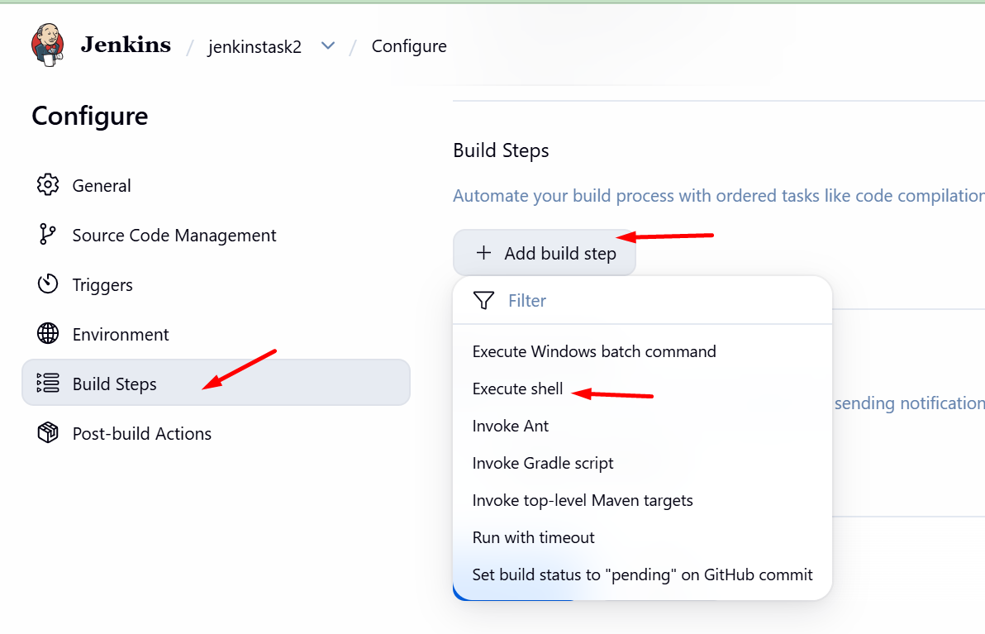
Add the below commands as shown in the below screenshot and save the configuration.
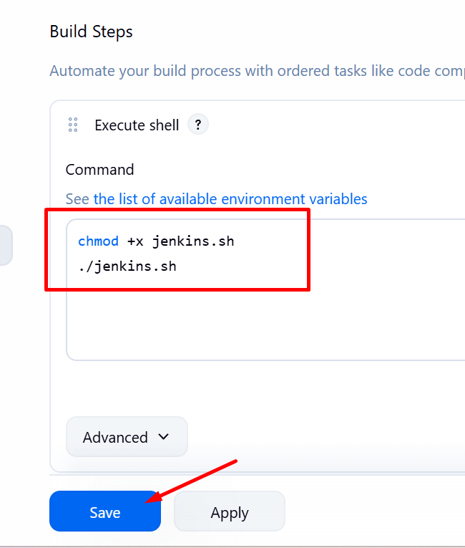

In the Triggers tab, Check the “Github hook trigger for GITScm polling”
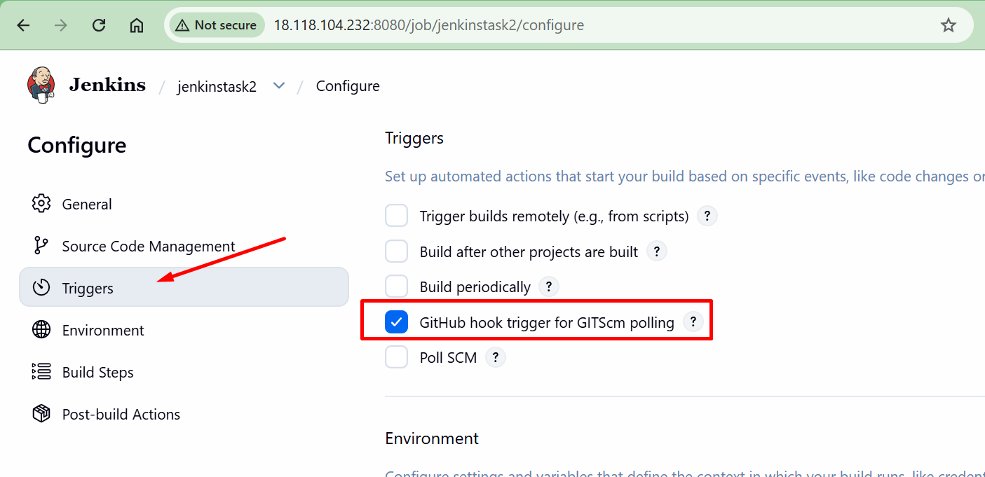

This tells Jenkins when GitHub receives a commit and trigger build.
Add the webhook
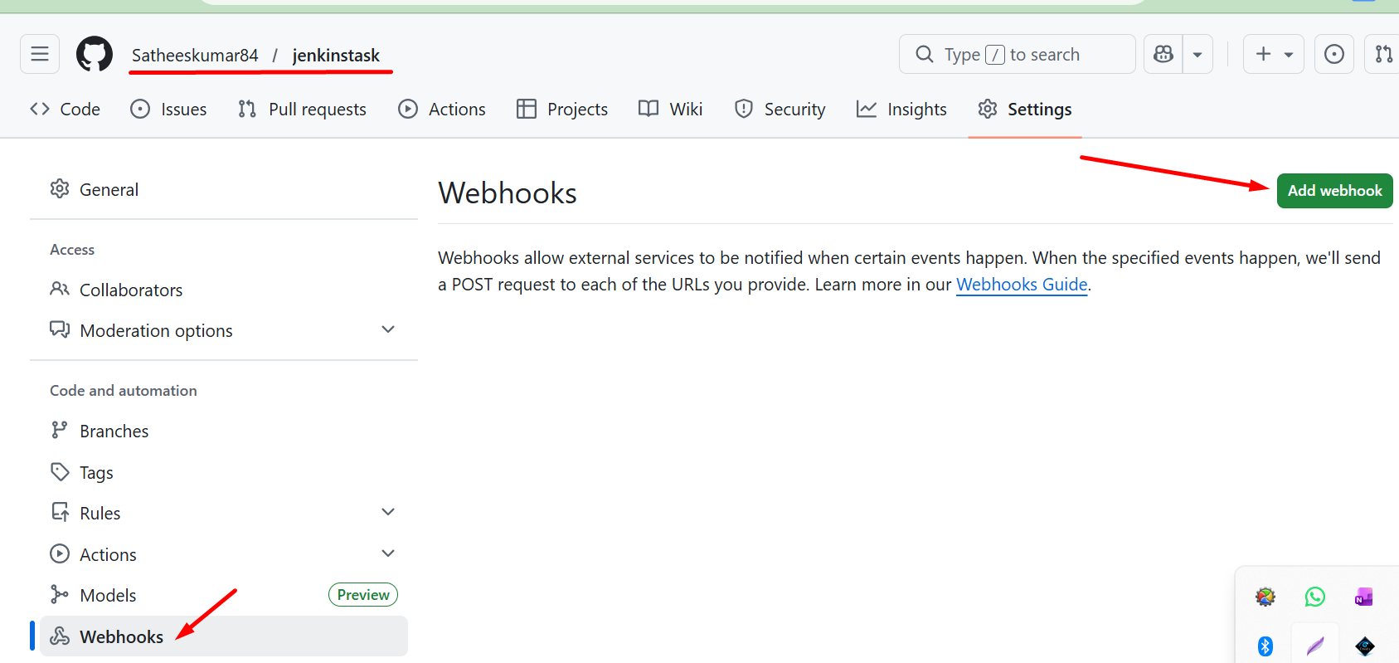

In the payload URL, enter the jenkins url as shown in the screenshot.
http://ipofthejenkins:8080/github-webhook.
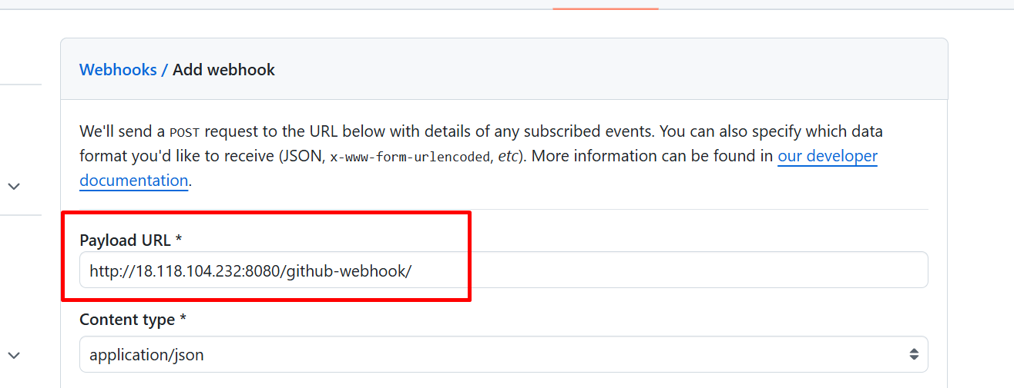

You can make sure the webhooks created successfully.
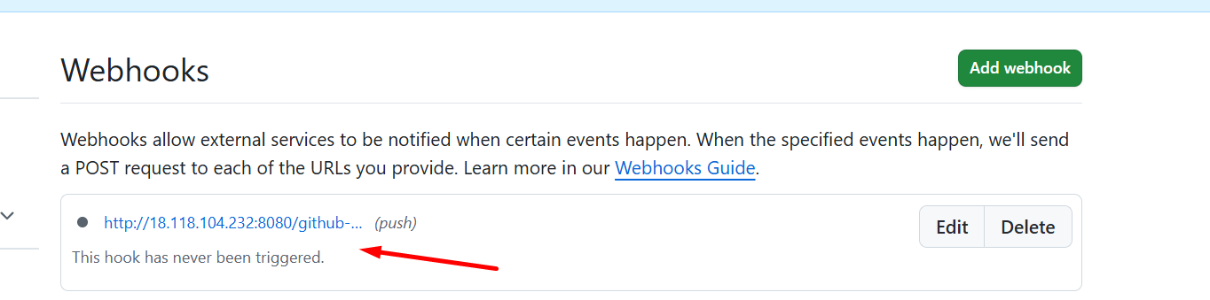

In the Build Steps, Select the Email Notification option and save it.
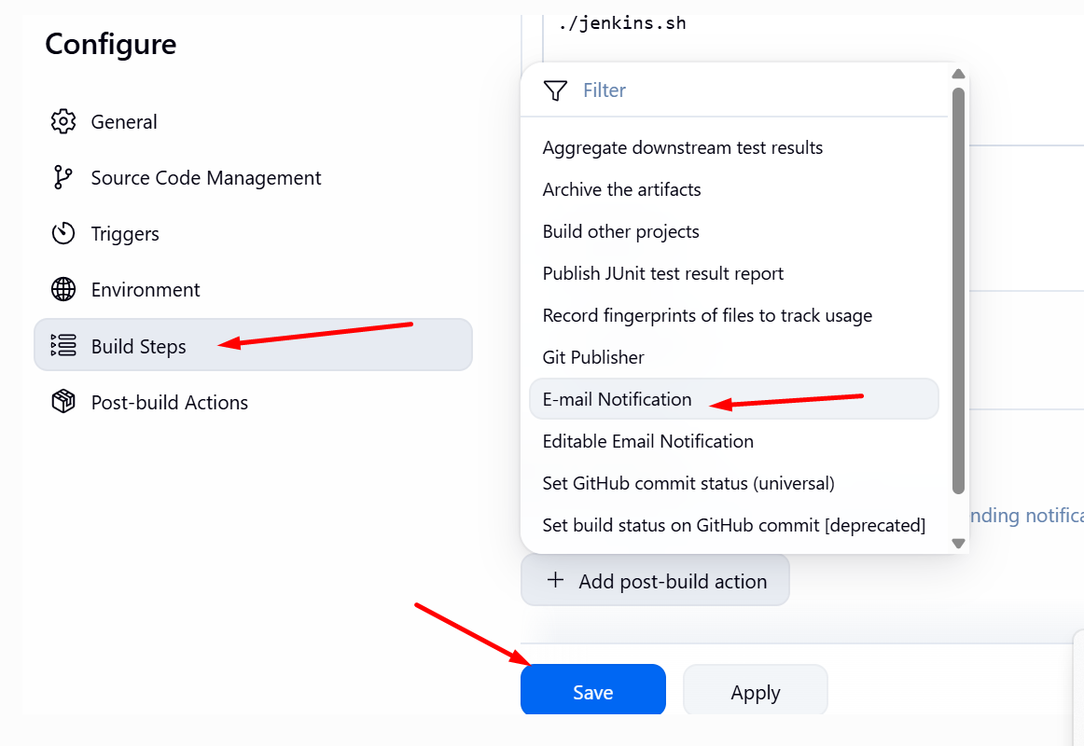

Enter the recipient email id to receive the emails.
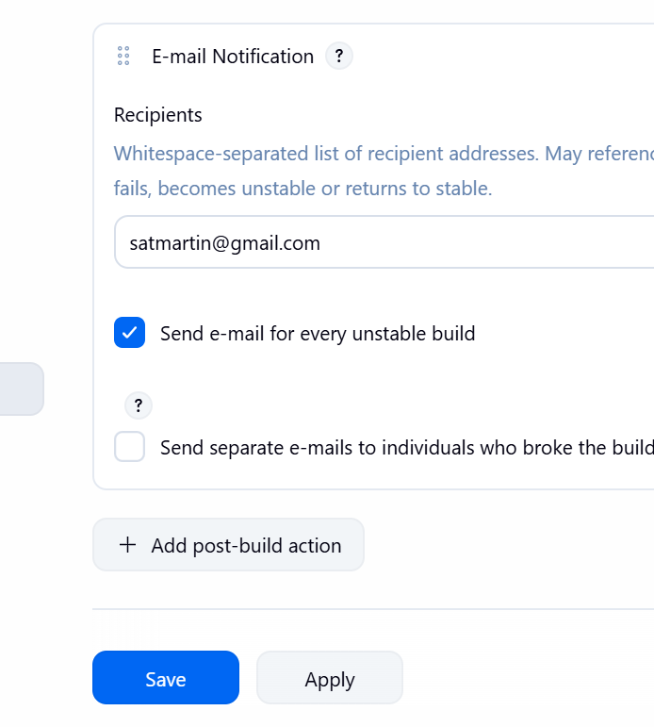

Made the commit to the script after a small change in it.
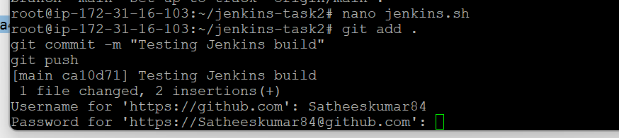

The commit successfully completed
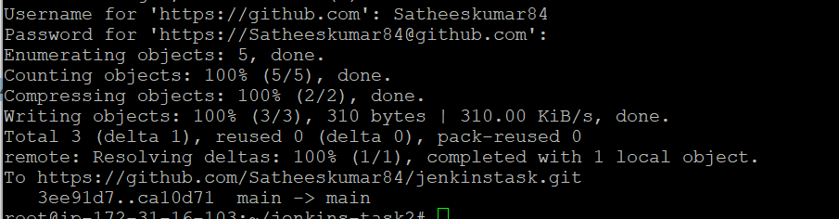

Received the email alert
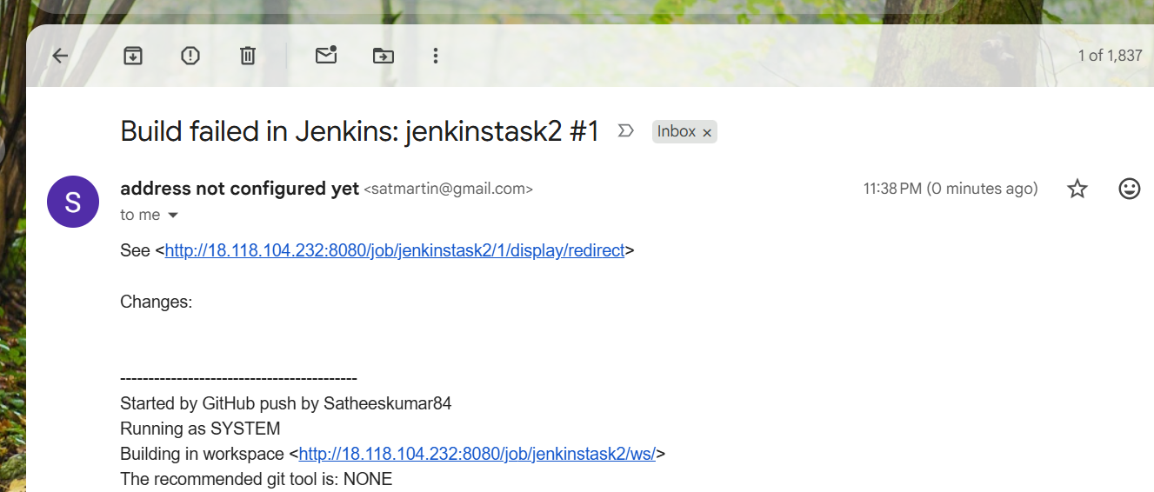

But the build was failed.

so checked the console output for the details and found there is small mistake in it and fixed that.
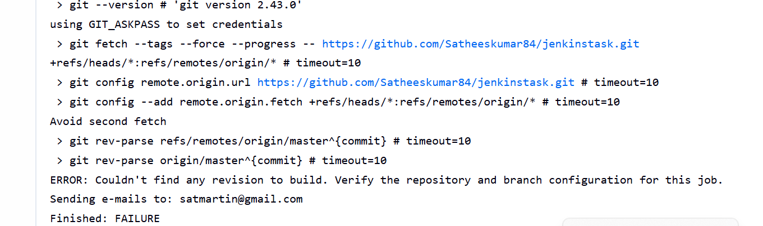

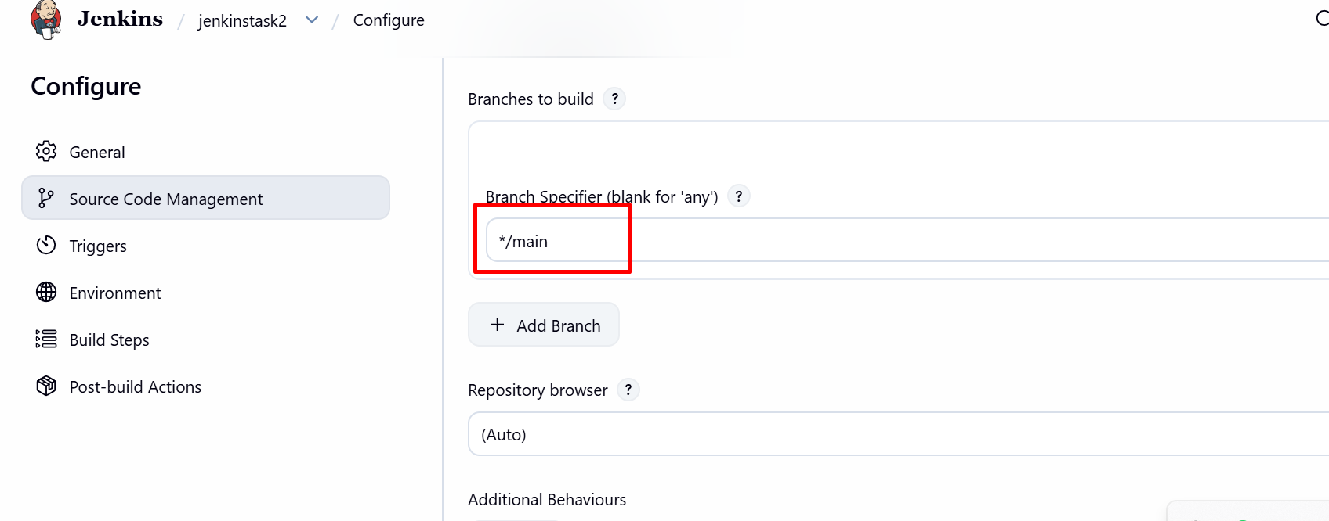

The build successfully completed, We got the expected output
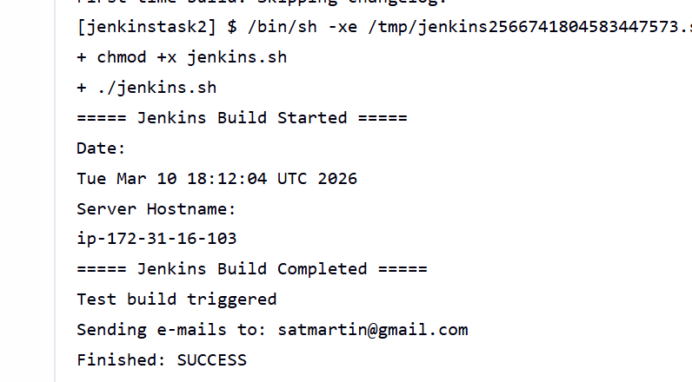

Also, I have received the email alert for the same.




